**COMP122 – Winter2017**

**Assigment1 _ Section 06**

**Question 1:**

SELECT last_name, DEPARTMENT_ID

FROM employees

WHERE employee_id=176

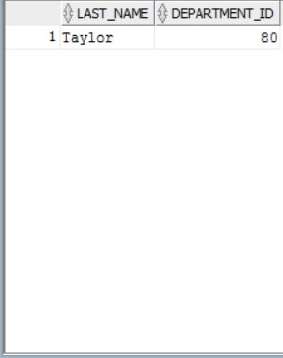

**Question 2:**

SELECT last_name, job_id, salary

FROM employees

WHERE job_id IN ('SA_REP', 'ST_CLERK')

AND salary <> 7000 AND SALARY <> 2500 AND SALARY <> 3500;

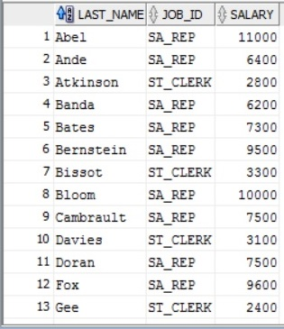

**Question 3:**

SELECT last_name || ' earns ' || SALARY || ' monthly but wants ' || (SALARY * 3)"Dream Salaries"

FROM EMPLOYEES

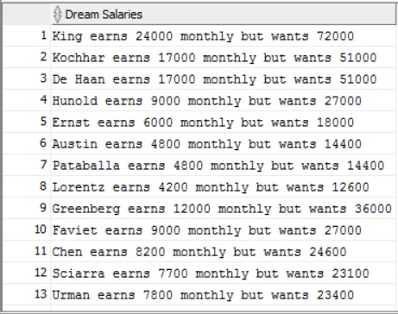

**Question 4:**

SELECT last_name, DEPARTMENT_ID

FROM EMPLOYEES

WHERE DEPARTMENT_ID=20

OR DEPARTMENT_ID=50

ORDER BY last_name ASC;

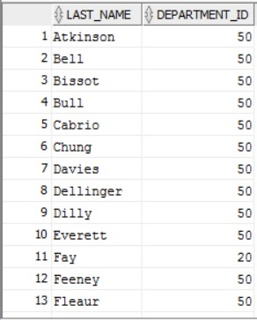

**Question 5:**

Is the same question as question 2